C372 CA2 AI Interaction Journal
Student ID | 24009059
Student Name | Raphaela Lee Boa Yu
Class | C372-004

Overview
In CA2, you will enable payments in the Supermarket App that you have worked on in CA1.

The AI Interaction Journal is designed to help you document, reflect on, and evaluate your use of generative AI tools (such as ChatGPT, Gemini, or Copilot) during the development of CA2 deliverable.

It promotes responsible and thoughtful use of AI, encouraging you to develop key skills in prompt design, critical evaluation of AI responses, and independent problem-solving.

This journal demonstrates how you used AI as a collaborative thinking partner—to explore ideas, test solutions, and deepen your understanding of code, rather than simply to produce answers.

In this journal:
- You will use this journal to record your key prompts, results, and reflections as evidence of how you engaged with AI responsibly throughout your project.
- You will need to identify the tasks related to the feature(s) you are building
- For each task, update the status, objective, goal(s), preparation work(s) for mentioned task, AI tool(s) used, entity table(s), relevant source code files, prompt(s) and results.

Note:
- Please read through the entire document before you begin.
- This AI Interaction Journal is part of CA2 Deliverable submission.
- Do not include personal information, passwords, API keys, or any confidential data. This log is for learning reflection and responsible AI use.

You may refer to C372 Individual Graded Assignment AI Interaction Journal – SAMPLE.docx for a reference on how to use this document.
Table of Contents
Overview 1
Enabling Payment Solution(s) in SupermarketAppMVC 3
Task Logs 4
Task 1 – Task 1 Name 4
OBJECTIVE 4
PROMPT(S) USED 4
AI RESPONSES/CODE GENERATED 4
RESULTS 4
Screenshots of the Payment Process Flow 5
Reflection on the use of GenAI for Enabling Payments 6

Note: Remember to update the table of contents for the latest updates to reflect above.

Enabling Payment Solution(s) in SupermarketAppMVC

- Identify the payment solution(s) you plan to implement in SupermarketAppMVC.
- PayPal and NETS QR were implemented. These payment methods were chosen because they are commonly used in Singapore supermarkets and align with the requirements of C372 Payment Technologies.

- Explain how you plan to implement the payment solution(s) identified in a).
- During checkout, the total cart amount is calculated server-side to prevent tampering.
- The PayPal JavaScript SDK is loaded on the checkout page.
- When the user clicks the PayPal button, an order is created using PayPal’s sandbox environment.
- Upon successful payment approval, PayPal returns an Order ID and Capture ID.
- These details are sent back to the server and stored for order confirmation and receipt display.

- In your chosen Generative AI tool (LLM), start a new chat session dedicated to your CA2 work.

Identify the tasks that are related to CA2. Add as many tasks as required.
Task No. | Task Name | Task Description
1 | Design payment flow | Planned the checkout and payment flow and I ensured that the payments were well integrated.
2 | Integrated paypal payment | Implemented the sandbox for paypal using paypal SDK to handle online-card based handling
3 | Integrated NETS QR payment | Implemented nets qr which stimulates a real supermarket QR payments when customers are paying
4 | Store payment | Saving payment method,transaction reference and order status which is in the database
5 | Tested and validated the payment flow | Tested both paypal and nets to ensure smooth flow and correct routing.

Entity Table(s)
List and define the key information needed to support payment solutions in your application.
Table Name:
Fields | Datatype
order_id | INT (Primary Key)
user_id | INT
total_amount | DECIMAL(10,2)
payment_method | VARCHAR(20)
order_status | VARCHAR(20)
created_at | DATETIME

Payment table
Fields | Datatype
payment_id | INT (Primary Key)
order_id | INT (Foreign Key)
payment_provider | VARCHAR(20)
transaction_reference | VARCHAR(100)
payment_status | VARCHAR(20)
paid_at | DATETIME

Task Logs
For each task, use the task template below:

Task 1 - Design and Implement Payment Flow (PayPal & NETS)
Date Started(DD/MM/YYYY): 15/1/26
Date Updated(DD/MM/YYYY): 15/1/2026
Status(Not started/In Progress/Completed): completed

OBJECTIVE
One high-level sentence to highlight what you want the AI tool to do.
(More details what you want the AI tool to do should be provided in your prompts.)
To use a generative AI tool to understand, design, and implement a complete payment flow for a supermarket application using PayPal and NETS QR.
GOAL(S)
- Goal 1: Design a clear and secure checkout payment flow suitable for a supermarket application.
- Goal 2: Successfully integrate PayPal and NETS QR payment options and ensure users receive payment confirmation.

PREPARATION WORK(S) FOR THE MENTIONED TASK
- Chatgpt
- Api sandbox for paypal
- Api for nets qr

AI TOOL(S) OR API USED
- AI tool 1
- AI tool 2
- API 1
- API 2

RELEVANT SOURCE CODE FILE(S)
- checkout.ejs
- checkoutController.js
- checkoutRoutes.js
- receipt.ejs

PROMPT(S) USED
Paste the key prompt(s) you used
Explain a NETS QR payment flow suitable for a supermarket app and how to redirect users after payment.”

AI RESPONSES/CODE GENERATED
Paste or summarize the AI-generated response/code. Note key implementation details, recommendations, and whether you used them.

For PayPal integration, the AI recommended:
- Creating PayPal orders server-side to prevent client-side amount tampering.
- Capturing payment only after user approval.
- Validating the payment status before marking an order as paid.
These recommendations were implemented in CheckoutController.js, where the total payable amount is calculated server-side using cart data before calling the PayPal service to create an order
CheckoutController
. The PayPal order creation and capture logic is handled through a dedicated service layer (services/paypal.js), which securely retrieves access tokens and communicates with the PayPal API using OAuth authentication
paypal
.
The AI also suggested storing non-sensitive payment proof instead of card details. This was applied by storing PayPal Order ID, Capture ID, and payer identifiers in the session after a successful capture, rather than saving any card information
CheckoutController
.
For NETS QR integration, the AI explained how a QR-based payment flow works in local supermarket environments. Based on this guidance, a NETS QR generation controller was implemented using Axios to call the NETS Sandbox API and render a QR code for users to scan
nets
. The AI also highlighted the importance of checking response codes and transaction status before displaying the QR code, which was implemented by validating the response_code and txn_status fields returned by NETS.
The AI-generated guidance was not copied verbatim. Instead, the suggestions were adapted to fit the existing SupermarketAppMVC structure and session-based checkout logic.

RESULTS
Describe if the output works as intended, how it was tested, and any remaining issues.
For PayPal payments, orders were successfully created and captured using the PayPal Sandbox environment. The application correctly validated that the payment status was "COMPLETED" before marking the order as paid and redirecting the user to the receipt page checkoutController, session data was cleared after checkout to prevent duplicate submissions.
For NETS QR payments, QR codes were generated successfully when valid cart totals were provided. The application correctly rendered success or failure views based on NETS API responses, ensuring that users were informed if a transaction failed or timed out
Nets. I did the testing using PayPal Sandbox buyer accounts to simulate successful and cancelled payments, Verifying server-side totals matched the captured payment amount and observing NETS QR generation and response handling. There were minor issues such as missing session data and incorrect redirects were identified during testing and resolved by refining controller logic and validation checks.

Screenshots of the Payment Process Flow
In this section, you should include clear screenshots of your application that illustrate each step of the payment process in your application, from initiating a payment to receiving confirmation. These visuals should demonstrate the user experience and help explain how the payment feature works within your app.

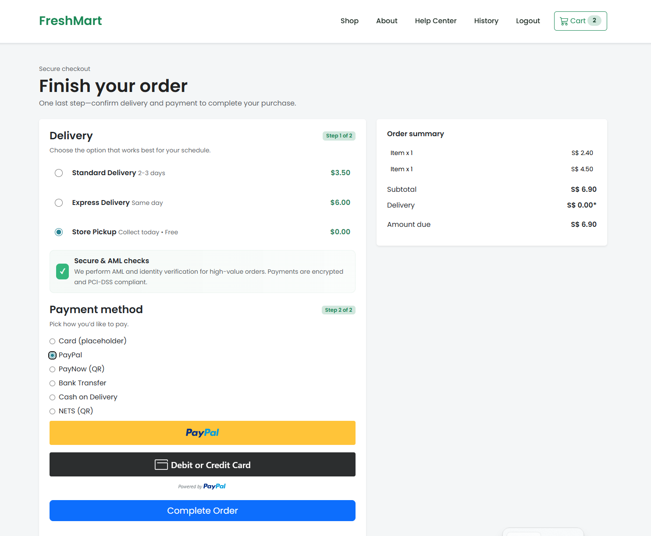

Task Logs
For each task, use the task template below:

Task 2 - Test and Validate Payment Flows
Date Started(DD/MM/YYYY): 15/1/26
Date Updated(DD/MM/YYYY): 15/1/26
Status(Not started/In Progress/Completed): completed

OBJECTIVE
One high-level sentence to highlight what you want the AI tool to do.
(More details what you want the AI tool to do should be provided in your prompts.)
To test PayPal and NETS payment flows for reliability and error handling.

GOAL(S)
- Verify successful payment scenarios
- Handle failed or cancelled payments

PREPARATION WORK(S) FOR THE MENTIONED TASK
- Created PayPal sandbox
- Prepared test cart scenarios

AI TOOL(S) OR API USED
- chatgpt
RELEVANT SOURCE CODE FILE(S)
- CheckoutController.js
- PayPalController.js
- nets.js

PROMPT(S) USED
Paste the key prompt(s) you used
“For a NETS QR payment flow using a sandbox API, what scenarios should be tested to confirm correct QR generation, response code handling, and failure states?”

AI RESPONSES/CODE GENERATED
Paste or summarize the AI-generated response/code. Note key implementation details, recommendations, and whether you used them.

For PayPal payments, the AI recommended testing:
- Successful PayPal order creation using a server-calculated total.
- Payment capture returning a "COMPLETED" status before marking the order as paid.
- Order mismatch scenarios where the PayPal Order ID stored in session does not match the captured Order ID.
- Cart total mismatch scenarios where the cart total changes after the PayPal order is created.
- Cancelled or incomplete PayPal payments where capture does not return a completed status.
For NETS QR payments, the AI suggested:
- Verifying that a QR code is generated only when the NETS API returns a success response code.
- Testing invalid or failed responses to ensure the failure page is rendered correctly.
- Ensuring the displayed payment amount matches the server-calculated cart total.
The AI did not generate full test code, but provided structured guidance on what conditions to validate based on the implemented controllers and payment flow logic.

RESULTS
Describe if the output works as intended, how it was tested, and any remaining issues.
For PayPal, successful payments correctly triggered order capture and redirected users to the receipt page with the order marked as paid. Payments were rejected when the session PayPal Order ID did not match the captured Order ID, or when the cart total differed from the stored pending total. Cancelled or incomplete PayPal payments were correctly blocked from proceeding to order confirmation.
For NETS QR, QR codes were generated only when the sandbox API returned a valid success response. Failed or invalid responses correctly redirected users to the NETS failure page instead of proceeding with checkout. In all cases, the payment amount displayed to the user matched the server-calculated cart total.
These tests confirmed that both payment flows handled success and failure scenarios reliably, and that validation logic prevented invalid or tampered payment attempts.

Screenshots of the Payment Process Flow
In this section, you should include clear screenshots of your application that illustrate each step of the payment process in your application, from initiating a payment to receiving confirmation. These visuals should demonstrate the user experience and help explain how the payment feature works within your app.
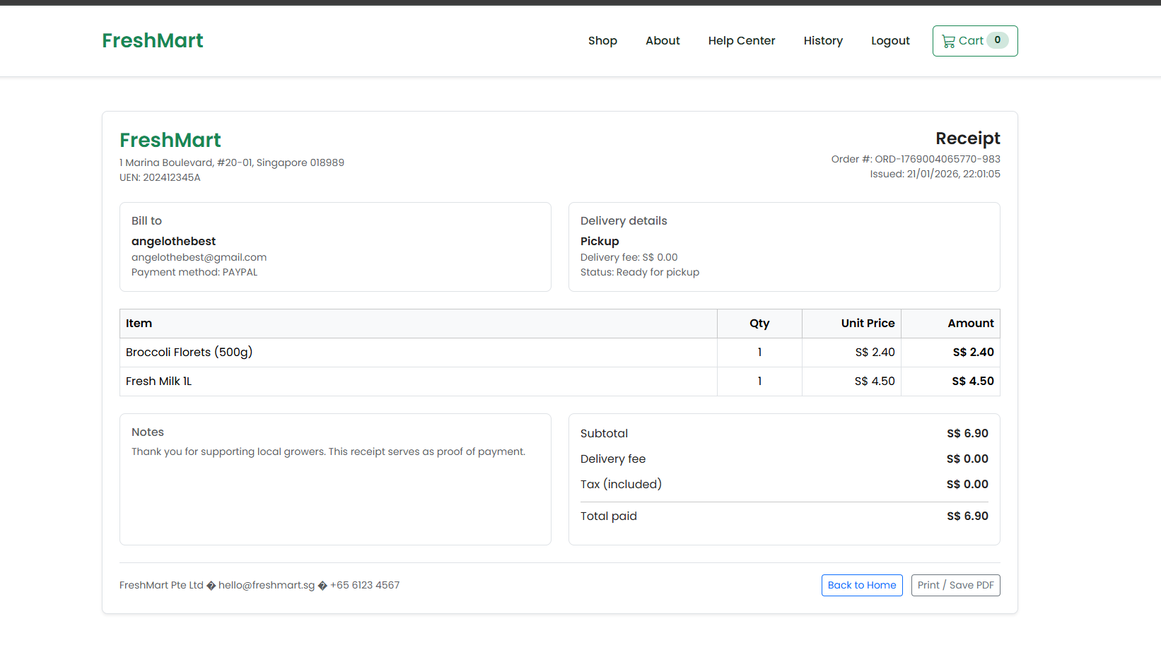
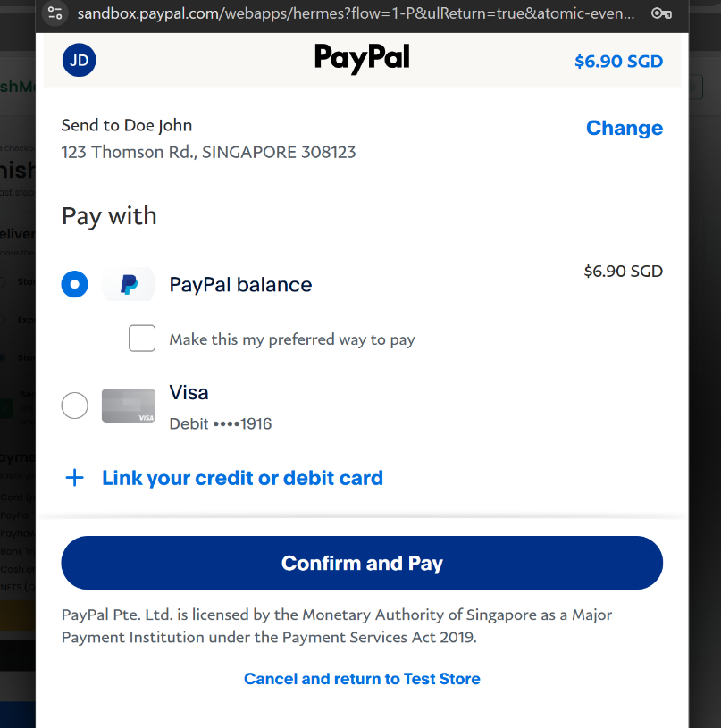

Task Logs
For each task, use the task template below:

Task 3- Prevent Duplicate or Replay Payments
Date Started(DD/MM/YYYY): 17/1/26
Date Updated(DD/MM/YYYY): 17/1/26
Status(Not started/In Progress/Completed): completed

OBJECTIVE
One high-level sentence to highlight what you want the AI tool to do.
(More details what you want the AI tool to do should be provided in your prompts.)
To ensure the same PayPal Order ID cannot be reused to confirm multiple orders.
GOAL(S)
- Session-based PayPal Order ID validation
- Clearing PayPal session data after successful checkout

PREPARATION WORK(S) FOR THE MENTIONED TASK
- Reviewed PayPal payment lifecycle to understand how Order IDs and Capture IDs are generated and reused.
- Analysed existing checkout logic to identify where PayPal payment confirmation occurs and how session data is stored.
- Reviewed security risks related to replay attacks and duplicate payment confirmation in web-based payment systems.

AI TOOL(S) OR API USED
- Chatgpt
- Paypal sandbox api

RELEVANT SOURCE CODE FILE(S)
- CheckoutController.js
- services/paypal.js

PROMPT(S) USED
Paste the key prompt(s) you used
“How do I prevent duplicate payment confirmation using the same PayPal Order ID in a Node.js Express checkout flow?”

AI RESPONSES/CODE GENERATED
Paste or summarize the AI-generated response/code. Note key implementation details, recommendations, and whether you used them.

The AI explained that PayPal Order IDs should be treated as single-use transaction references and must be validated server-side before confirming an order. It highlighted that replay attacks can occur if the same Order ID is reused to trigger payment confirmation multiple times.
Based on this guidance, the AI recommended:
- Storing the pending PayPal Order ID and expected total amount in the server session when the order is created.
- Verifying that the captured PayPal Order ID matches the pending Order ID stored in the session.
- Clearing PayPal-related session data immediately after a successful checkout to prevent reuse.
- Rejecting payment confirmation attempts if session data is missing or does not match.
These recommendations were applied in the checkout logic, where PayPal Order IDs are validated before marking an order as paid and session data is cleared after successful order placement.
The AI did not generate final code directly but provided validation strategies that were adapted to fit the existing SupermarketAppMVC architecture.

RESULTS
Describe if the output works as intended, how it was tested, and any remaining issues.
When a PayPal payment was successfully completed, the Order ID and Capture ID were validated and the order was marked as paid. After checkout, PayPal-related session data was cleared. Any attempt to reuse the same PayPal Order ID resulted in an error message and redirection back to the checkout page.
Additional testing confirmed that:
- A second confirmation attempt using the same PayPal Order ID was rejected.
- Orders were not marked as paid when session PayPal data was missing or mismatched.
- Users were required to initiate a new payment attempt for each order.
This ensured that each PayPal transaction could only be used once, effectively preventing duplicate or replay payment attacks.

Screenshots of the Payment Process Flow
In this section, you should include clear screenshots of your application that illustrate each step of the payment process in your application, from initiating a payment to receiving confirmation. These visuals should demonstrate the user experience and help explain how the payment feature works within your app.

Specific id for the payment

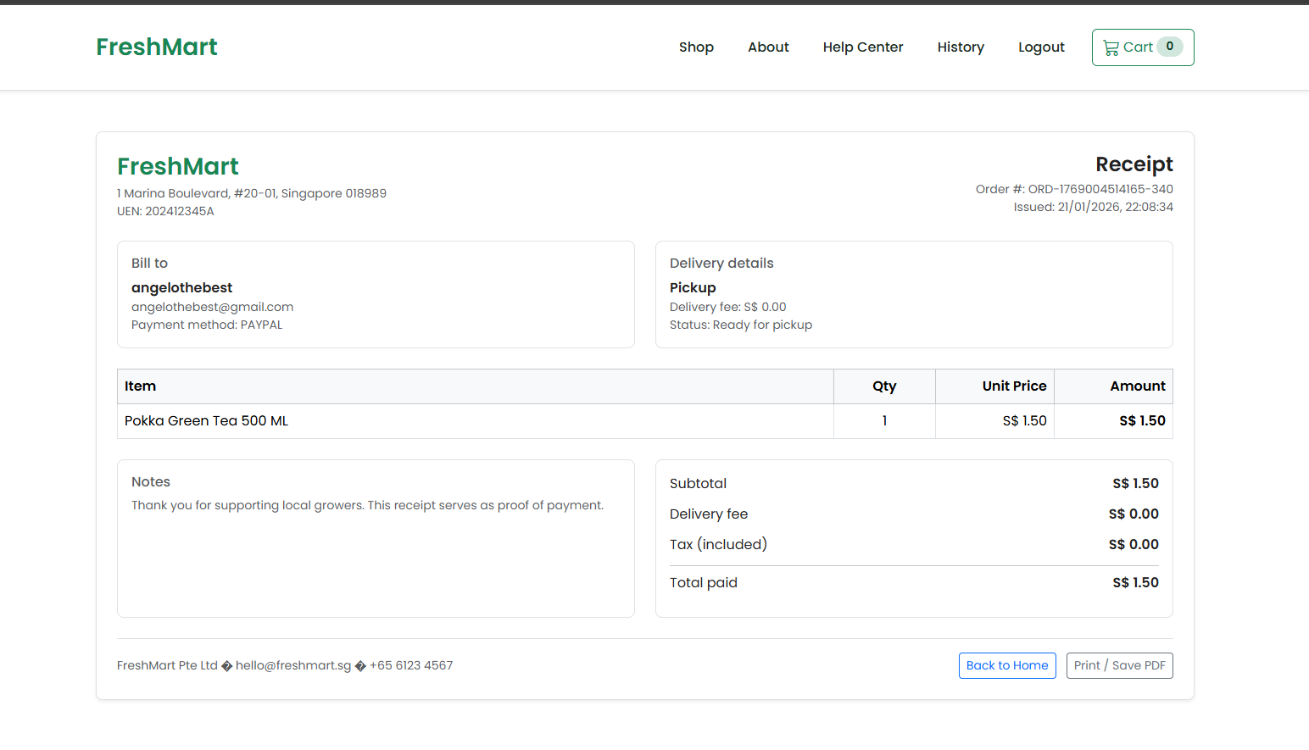

Task Logs
For each task, use the task template below:

Task 4- refund
Date Started(DD/MM/YYYY): 27/1/26
Date Updated(DD/MM/YYYY): 28/1/26
Status(Not started/In Progress/Completed): completed

OBJECTIVE
One high-level sentence to highlight what you want the AI tool to do.
(More details what you want the AI tool to do should be provided in your prompts.)
Use AI to assist in designing and implementing refund and transaction handling logic for the payment system, ensuring accurate status updates and error handling.

GOAL(S)
- Implement a refund flow that correctly updates transaction and order status
- Ensure failed or cancelled payments are handled safely and consistently

PREPARATION WORK(S) FOR THE MENTIONED TASK
- Reviewed existing payment and order database structure
- Identified scenarios requiring refunds (payment failure, user cancellation)
AI TOOL(S) OR API USED
• ChatGPT
• PayPal Sandbox API
• NETS API

RELEVANT SOURCE CODE FILE(S)
• paymentController.js
• orderController.js

PROMPT(S) USED
Paste the key prompt(s) you used
“How do I integrate refund for the payment section”

AI RESPONSES/CODE GENERATED
Paste or summarize the AI-generated response/code. Note key implementation details, recommendations, and whether you used them.

The AI provided sample refund logic using PayPal APIs, including validating transaction IDs before processing refunds. It also recommended separating payment status and order status to avoid inconsistencies.
I adapted the code to fit my existing controllers and database structure instead of directly copying it.

RESULTS
Describe if the output works as intended, how it was tested, and any remaining issues.
The refund logic works as intended. Refunds were tested using PayPal Sandbox transactions, and order statuses updated correctly after refunds.
Remaining limitation: NETS refunds require manual handling due to API constraints in the UAT environment.

Screenshots of the Payment Process Flow
In this section, you should include clear screenshots of your application that illustrate each step of the payment process in your application, from initiating a payment to receiving confirmation. These visuals should demonstrate the user experience and help explain how the payment feature works within your app.

Task Logs
For each task, use the task template below:

Task 1 – Task 1 Name
Date Started(DD/MM/YYYY):
Date Updated(DD/MM/YYYY):
Status(Not started/In Progress/Completed):

OBJECTIVE
One high-level sentence to highlight what you want the AI tool to do.
(More details what you want the AI tool to do should be provided in your prompts.)

GOAL(S)
- Goal 1
- Goal 2

PREPARATION WORK(S) FOR THE MENTIONED TASK
- Prepared item 1
- Prepared item 2

AI TOOL(S) OR API USED
- AI tool 1
- AI tool 2
- API 1
- API 2

RELEVANT SOURCE CODE FILE(S)
- File1.js
- File2.js

PROMPT(S) USED
Paste the key prompt(s) you used

AI RESPONSES/CODE GENERATED
Paste or summarize the AI-generated response/code. Note key implementation details, recommendations, and whether you used them.

RESULTS
Describe if the output works as intended, how it was tested, and any remaining issues.

Screenshots of the Payment Process Flow
In this section, you should include clear screenshots of your application that illustrate each step of the payment process in your application, from initiating a payment to receiving confirmation. These visuals should demonstrate the user experience and help explain how the payment feature works within your app.

Reflection on the use of GenAI for Enabling Payments
Focus on how you engaged with generative AI as a learning partner while implementing payment functionality.
Your responses should include specific examples from your code to demonstrate critical thinking, testing, and ethical awareness in your use of AI.

- How did you use GenAI to understand payment integration requirements?
Describe how you used AI tools to research payment solutions, clarify requirements, or explore best practices for secure payment processing. What resources or guidance did AI provide that shaped your approach?

- What challenges did you face when enabling payments, and how did GenAI help you address them?
Reflect on any technical, security, or design challenges you encountered while implementing payments. How did you use AI to troubleshoot, generate code, or find solutions? Provide examples.

- How did you ensure the payment feature was secure and reliable?
Explain how you used AI to check for security vulnerabilities, validate payment flows, or follow industry standards. Did AI help you identify potential risks or suggest improvements?.

- How did you test and validate the payment functionality with the help of GenAI?
Describe your process for testing the payment feature. Did you use AI to generate test cases, debug errors, or verify that transactions were processed correctly? What changes did you make based on AI feedback?

- What limitations or risks did you notice in the AI’s suggestions for payment integration?
Critically evaluate the AI’s responses. Did it ever suggest insecure, outdated, or non-compliant solutions? How did you identify and address these issues?

- How did you balance AI assistance with your own learning and decision-making?
Discuss how you ensured that using AI enhanced your understanding of payment systems, rather than just providing answers. What steps did you take to independently review, test, or adapt AI-generated solutions?

